Arts and disability interfaces

new technology, disabled artists and audiences
part 3 of 3: pervasive computing: a special report

Contents:
Document meta data 2
Abstract 2
Introduction 3
Cultural and social aspects - an example 4
Projects and Technologies 5
MIT – Project Oxygen 5
Overview 5
Technologies 5
Speech and Visiontask at hand 5
E21 stationary devices 6
H21 hand-held devices 6
N21 networks 6
Spoken language, sketching and visual cues 7
MikeTalk 7
Object tracking and recognition 7
Trip - a low-cost tracking system 8
IBM - the 'Everyplace Wireless Gateway' 9
SIMPad - carrying the web around 10
Smart Spaces 10
MEMS - complete systems on a microchip 12
Devices with DNA Software 12
Gesture-based gadget-control 13
Optical-Fibre fabric 14
Ambient computing and devices 15
The Play Group - informative art and slow technology 15
Ambient devices 15
LCD paint 16
Networks 17
The network 17
Network services 17
Network users 17
Network devices 18
Network distribution channels 18
Conclusion 18

Document meta data
Name: pervasive-technology.doc
Title: Arts and disability interfaces: new technology, disabled artists and audiences part 3 of 4: pervasive computing special report
Relation: Disability Interfaces scoping study, document 3 of 4
Identifier: (if/when available online, URL required here)
Publisher: the Arts Council of England
Date: 02.11.02
Version: 1.0
Status: final
Type: scoping study
Language: en
Format: Microsoft Word
Coverage: Europe, UK, USA, Australia
Creator: Mike Quantrill, email: m.p.quantrill@lboro.ac.uk
Contributor: David Everitt, role: researcher, editor
Subject: the arts, disability and technology
Keywords: technology, disability, disabled, access, equality, assistive, impairment, art, audiences, ubiquitous, computing, computers, software, pervasive, digital, creative
Description: an explanation pervasive computing, with background information and examples
Rights: The creator of this document grants to the Arts Council of England or its agents the right to archive and to make the document or its contents in whole or in part available through the Arts Council, in all forms of media. The creator retains all proprietary rights, and the right to use all or part of this document in future works, with due reference to the Arts Council.

Abstract
This paper is the third part of a study commissioned by the Arts Council (commencing April 2002) to scope and define a long-term project (to follow this study, possibly commencing late 2002) that will research new and emerging technology of existing and potential use to disabled artists, arts practitioners and audiences. It describes the movement in computing towards what is known variously (along with other terms) as 'pervasive', 'ubiquitous', 'transparent' or 'persistent'. Combinations of technologies allow computing technology to be concealed in or integrated with the human environment. With intelligent software that can learn about a user's requirements, computing can be then controlled by gesture, voice and other 'casual' methods. The implications for some disabled users are immediately apparent, as this is a form of computing without intrusive technological and often inaccessible devices; making today's assistive technologies appear crude and clumsy by comparison. To be of maximum use to potential interested parties, this report is fairly technical in places, but there are also examples of projects and products.

Introduction
Individuals, organisations and groups have defined pervasive technology as they see it. Sometimes the emphasis is upon the devices that are designed to enable pervasive computing, sometimes the emphasis is upon the human aspects associated with it. Briefly, pervasive computing is a significant evolution of computing technology that integrates three main trends in current computing:
- numerous, casually accessible, often invisible computing devices
- mobile devices or technology embedded in the environment
- connection to an increasingly ubiquitous network structure

According to SDForum, Pervasive computing, is a vision of the next generation of computing devices. Mark Weiser and John Seely Brown of Xerox PARC, defined it in 1996 as
'the third wave in computing, just now beginning. First were mainframes, each shared by lots of people. Now we are in the personal computing era, person and machine staring uneasily at each other across the desktop. Next comes ubiquitous computing, or the age of calm technology, when technology recedes into the background of our lives.
The computer science journal IEEE Pervasive Computing states,
'The essence of [the vision of pervasive computing] is the creation of environments saturated with computing and wireless communication, yet gracefully integrated with human users. Many key building blocks needed for this vision are now viable commercial technologies: wearable and handheld computers, high bandwidth wireless communication, location sensing mechanisms, and so on. The challenge is to combine these technologies into a seamless whole. This will require a multidisciplinary approach, involving hardware designers, wireless engineers, human-computer interaction specialists, software agent developers, and so on.'
The area of pervasive computing and all it encompasses is daunting in its scope, as the following extracts show:
'As computing dissolves into the environment it will become as pervasive as the electricity flowing through society. In a controversial prediction, some scientists suggest the earth will be wrapped in a "digital skin", transmitting signals over the Internet almost as a living creature relays impulses through its nervous system. Millions of sensors will probe and monitor highways, cities, factories, forests, oceans, and the atmosphere. Some will be linked to orbiting satellites - extending the reach of this digital infrastructure into outer space.
Neil Gershenfeld, the co-director of the Things That Think consortium [at the MIT Media Lab], admits he no longer tries predicting when some futuristic technology might appear because it almost invariably turns up years before he thought it would. Much of the basic infrastructure for ubiquitous computing is actually already here - the Internet is up and running, processing power is increasing daily, and advances in wireless technology are exploding. For example, emerging systems […] will soon increase wireless data rates to two megabits per second; fast enough to download songs and movies from the Web. This capacity points to a future in which handheld devices are used to access a wide range of databases and other kinds of networked tools.
Gershenfeld also states, reflecting on the bits and the atoms, "The bits are the good stuff," referring to these units of digital information. "They consume no resources, they travel at the speed of light, we can copy them, they can disappear, we can send them around the globe and construct billion dollar companies." Contrasting them with physical objects, he says, "The atoms are the bad stuff. They consume resources, you have to throw them away, they're old-fashioned." A challenge for the millennium, he explains, is to find ways to "bring the bits into the physical world."
“The basic idea behind linking bits and atoms is finding ways of getting physical objects to communicate with computers through a digital network. Technologists see this as a way to liberate computing from the confines of the PC and bring it out into the world at large. John Seely Brown, the chief scientist at Xerox, compares computing today to "walking around with your peripheral vision blocked by a pair of tubes on your glasses." And Gershenfeld says the problem with PCs now is that they only touch that "subset of human experience spent sitting in front of a desk." Both scientists say that to be truly useful, computers should be brought into the stuff of everyday life, in part by embedding them into ordinary objects and machines.”

Cultural and social aspects - an example
As an example of the differing social and cultural needs amongst differing societies the following comments contrast and compare the adoption of new technologies by Japan and the west.

Internet use in the United States in particular and also Europe has substantially impacted the way people shop, trade stocks, manage funds, educate, and even participate in politics. Current Japanese use of the Internet is more about novel entertainment or advertising. This contrast comes from different necessities of having computer-enabled information access at home. Whereas U.S. consumers may look for information about products and services on the Internet, Japanese consumers often already have it through a much higher exposure to advertisements, magazines, and papers they read on the train while commuting, or from ubiquitous billboards visible on most major streets. For shopping, Japanese retail shops are located within a few steps of offices, train stations, and homes. In such a society, it makes more sense to go out and buy what's needed rather than logging on and surfing the net. Pervasive computing offers ubiquitous access to information without requiring much user effort. U.S. consumers may welcome this as a radical change in information access, but Japanese consumers may see it as redundant. The value of pervasive computing in a society such as Japan, where people closely communicate and share common means of engaging in social activities, may be in enhancing interpersonal communication. Sending and receiving messages on handheld devices will be in great demand, and enabling devices to interface with others will greatly accelerate pervasive computing.

Technologies can change the way people work, live, and commute. Many 'first-world' citizens are coming to depend on various appliances and devices such as the telephone, TV, and microwave. For many, it would be difficult to live without the convenience and services these provide. The future may offer enhanced wearable devices (not only hearing aids and pagers, but identity transponders worn on the body that allow self-service checkout at the cashier-free supermarket by debiting the customer's account), imbedded devices (blind users of brain-imbedded visual sensors), and perhaps high-tech piercing, based on form or function.

Home appliances already have adopted pervasive computing functions in Japan. Some appliance manufacturers have introduced microwave ovens that download cooking recipes from the manufacturer's server. Although not Net-connected, rice cookers have long been equipped with microchips that control the heating sequence. Air conditioners also have used sophisticated temperature control employing "fuzzy" logic. All have the potential to become interactive. This sophistication in home appliances in Japan may be attributed to the fact that many families emphasise domestic activities such as cooking, cleaning, and maintaining housing. It may take comparatively longer for the United States to adopt appliance computerisation because households take less time to engage in such domestic activities. In financial applications, the use of cash is preferred by far over credit cards in Japan, and personal cheques are virtually unused. Europe and US society have long adopted cashless monetary settlements which can be easily converted for connection with pervasive devices. In this context, adoption of pervasive computing may be characterised as interpersonal and domestic in Japan, and business oriented and social in the US and Europe. It follows that the adoption of pervasive computing by disabled people will follow patterns defined by the requirements of the individual within (possibly multiple) social contexts.

Projects and Technologies
Pervasive computing is a relatively new area of research. However the are numerous projects world-wide. These projects address the social, task and device issues raised by, what appears to be a major shift in our perception of computing and its affordances. Some of these projects and technologies will now be listed.

MIT – Project Oxygen

Overview
In the future (according to MIT), computation will be human-centered; it will enter the human world, handling our goals and needs and helping us to do more by doing less. Computation will be pervasive, like batteries, power sockets, and the oxygen (of the project title) in the air we breathe. Configurable generic devices, either handheld or embedded in the environment, will bring computation to us, whenever we need it and wherever we might be. As we interact with these 'anonymous' devices, they will adopt our information personalities. They will respect our desires for privacy and security. We won’t have to type, click, or learn new computer jargon. Instead, we’ll communicate naturally, using speech and gestures that describe our intent ('send this to Hari' or 'print that picture on the nearest printer'), and leave it to the computer to carry out our will.
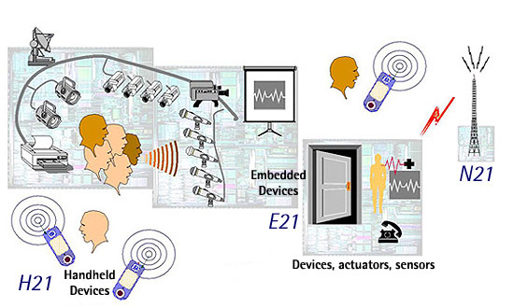

Technologies

Speech and Visiontask at hand
Oxygen’s user technologies directly address human needs. Speech and vision technologies enable us to communicate directly with Oxygen as if interacting with another person. Automation, individualized knowledge access, and collaboration technologies help us perform a wide variety of tasks in ways we prefer.

Oxygen’s system technologies dramatically extend our range of capabilities by delivering user technologies to us at home, at work, or on the go. Computational devices, Enviro21s (E21s), embedded in homes, offices and vehicles sense and affect our immediate environment. Hand-held devices, called Handy21s (H21s), empower us to communicate and compute no matter where we are. Dynamic networks (N21s) help our machines locate each other as well as the people, services, and resources we want to reach. These are explained below.

E21 stationary devices
Embedded in offices, buildings, homes, and vehicles, and often linked to local sensors and actuators, E21s enable the creation of 'situated entities' (combinations of various technologies) that can perform functions on our behalf, even in our absence. For example, we can create entities and place them to monitor and change the temperature of a room, close a garage door, or redirect email to colleagues, even when we are thousands of miles away. E21s provide large amounts of embedded computation, as well as interfaces to camera and microphone arrays, thereby enabling us to communicate naturally, using speech and gesture, in the spaces they define.

H21 hand-held devices
Users can select hand-held devices, called H21s, appropriate to the tasks they wish to perform. These devices accept speech and visual input, can reconfigure themselves to perform a variety of useful functions, and support a range of communication protocols. Among other things, H21s can serve as cellular phones, beepers, radios, televisions, geographical positioning systems, cameras, or personal digital assistants, thereby reducing the number of special-purpose gadgets we must carry. To conserve power, they may offload communication and computation onto nearby stationary devices (E21s).

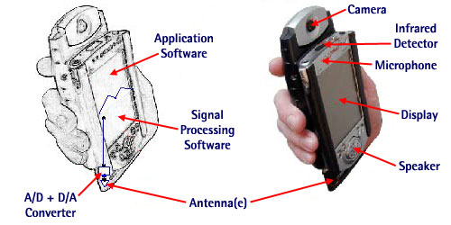

N21 networks
N21s support dynamically changing configurations of self-identifying mobile and stationary devices. They allow us to identify devices and services by how we intend to use them, not just by where they are located. They enable us to access the information and services we need, securely and privately, so that Oxygen is comfortably integrated into our personal lives. N21s support multiple communication protocols for low-power local, building-wide, and campus-wide communication, enabling us to form collaborative regions that arise, adapt, and collapse as needed.

Spoken language, sketching and visual cues
Spoken language and visual cues, rather than keyboards and mice, define the main modes of interaction with Oxygen. By integrating these two technologies, Oxygen can better discern our intentions, for example, by using vision to augment speech understanding through the recognition of facial expressions, gestures, lip movements, and gaze. These perceptual technologies are part of the core of Oxygen, not just afterthoughts or interfaces to separate applications. They can be customized quickly in Oxygen applications to make selected human-machine interactions easy and natural. Graceful switching between different domains (e.g. from a conversation about the weather in Rome to one about airline reservations) supports seamless integration of applications.
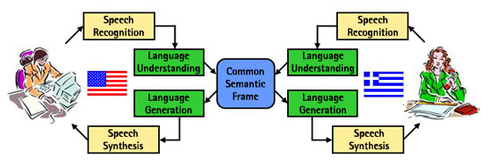

MikeTalk
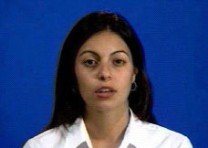
This is an example of the advanced kind of voice and video recognition required for possible control methods in pervasive, computing. A photorealistic text-to-audiovisual speech synthesiser, MikeTalk processes a video of a human subject (uttering a predetermined speech corpus) to learn how to synthesise the user's mouth for arbitrary utterances not included in the original video. The output is videorealistic in the sense that it looks like a video camera recording of the subject, complete with natural head and eye movements.

Object tracking and recognition
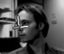
A real-time object tracker uses range and appearance information from a stereo camera to recover an object's 3D rotation and translation. When connected to a face detector, the system accurately tracks head positions, thereby enabling applications to perceive where people are looking.

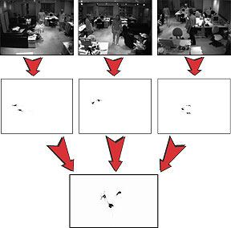

A person-tracking system uses three camera modules, each consisting of stereo camera and a computer, that are arranged to view an entire room and continually estimate 3D-point clouds of the objects in the room. The system clusters foreground points into blobs that represent people, from which it can extract features such as a person's location and posture.

Trip - a low-cost tracking system
At the Laboratory for Communications Engineering, University of Cambridge, Diego Lopez has developed a low cost tracking system using simple web cams and circular barcodes on paper disks. The system is called TRIP. Using barcodes on small paper disks:
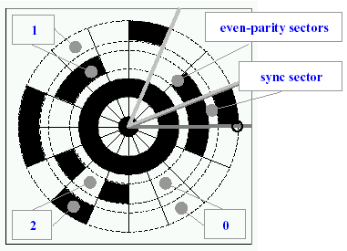

TRIP employs off-the-shelf hardware (low-cost CCD cameras and PCs) and printable 2-D circular markers for entity identification and location. The usability of TRIP is illustrated through the implementation of several sentient applications.

TRIP applies a target recognition algorithm to the raw video data supplied by a camera in order to determine the identifiers and geometric properties of the projections of TRIPtags in a frame. This procedure converts the TRIP system into an 'entity identification' sensor.

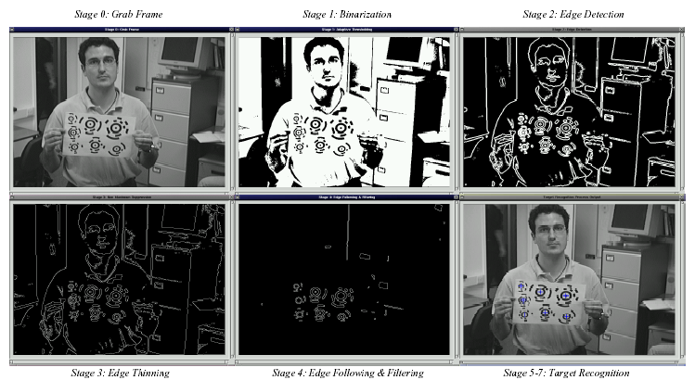

Stages in identifying and locating TRIPtags on a sheet of paper. These could equally be attached to a user’s clothing.

IBM - the 'Everyplace Wireless Gateway'
IBM has developed the capability to offer seamless, secure roaming between different types of wireless networks including Wireless Local Area Networks (LAN), cellular, private mobile radio and satellite networks. The 'Everyplace Wireless Gateway' solution enables access to critical (business in the case of IBM) data at all times, moving locations while roaming over different types of networks, using different types of wireless device.

Generally, devices that can access different types of wireless network applications need to be restarted when changing networks. IBM's Everyplace Wireless Gateway automatically detects the most appropriate wireless network at any given time and can switch networks without the need to restart the device or the application. For example, someone at home can access data from a home wireless LAN network. After leaving the house (and the range of the wireless LAN network), the device automatically switches over to a cellular network. Upon entering an office or other location the device can switch over to a higher speed Wired or Wireless Local Area Network.

The solution also recognises the most appropriate time and network to transfer large amounts of data to and from the device and back end systems, avoiding the use of more costly, slower speed cellular networks if large amounts of data that can wait for a less expensive, higher bandwidth Wi-Fi or Wireless LAN network.

SIMPad - carrying the web around
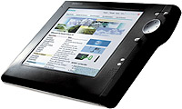
As a small example of the 'carry-with-you' kind of computing that depends on wireless connection, German manufacturer Siemens has recently unveiled a device it calls the Gigaset 4600 SIMpad that allows you to 'carry the Web' around. It's one of several 'Web pads' either in development or coming to market now. When turned on you have almost instant access to the Web. It runs on Windows CE operating system and Internet Explorer, and weighs about two pounds.

Mobile Web access is made possible by a wireless networking connection, that allows the SIMpad to share an Internet connection with your home's main PC from as far away as 150 feet. Home RF currently works at a speed of about 1.6 megabits per second, though its backers are pushing that speed up to 10 megabits per second later this year.

The pad looks like a cross between a PC and PalmPilot and comes complete with a pen and a touch-sensitive screen that is 800 pixels long by 600 wide. The unit has an Intel StrongARM processor running at 200 megahertz. Instead of a hard drive it contains 16 megabytes of flash memory.

Smart Spaces
The smart space group is an interdisciplinary team of professionals with diverse computing skills. They are part of the Information Technology Laboratory (ITL), located in Gaithersburg, Maryland, USA.

Smart Spaces are work environments with embedded computers, information appliances, and multi-modal sensors allowing people to perform tasks efficiently by offering unprecedented levels of access to information and assistance from computers.
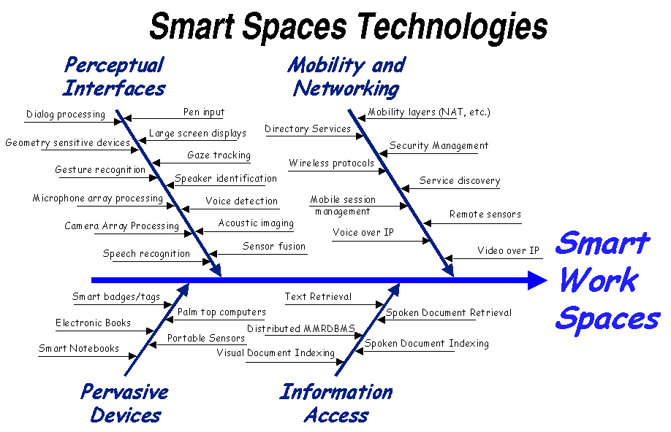
There are numerous technologies and products that may be combined in the 'smart spaces' of the future (workplace examples are typically used). NIST has developed an integrating platform designed to promote interoperability, data transport, and distributed processing that should make it easier to bring these many products together. Smart Work Spaces will make use of numerous aspects of pervasive computing,

Smart Spaces' aim is for easier computing, available everywhere it's needed. They support stationary and mobile information environments that may be connected to the Internet. Companies are producing various portable and embedded information devices for mobile information environments including PDAs, cellular telephones and active badges. Concurrently, wireless technologies, including Bluetooth, IrDA, and HomeRF, will outfit these devices with high bandwidth and localized wireless capabilities to enable communication with each other and the global Internet.

Smart Spaces offer services provided by embedded devices, accessed and interconnected with carried or worn portable devices brought into the spaces. The combination of imported and existing native devices supports the information needs of users. Mobile and stationary Smart Spaces may:
- identify and perceive users, their actions, and even goals;
- facilitate interaction with information rich sources;
- provide extensive presentation capabilities;
- anticipate user needs during task performance;
- provide improved records and summaries for later use;
- support distributed and local collaboration.

MEMS - complete systems on a microchip
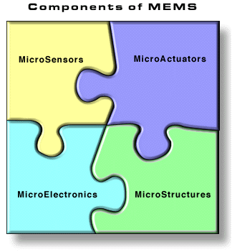
A very interesting area of research into sensors, a key component of pervasive systems, is Micro-Electro-Mechanical Systems (MEMS). MEMS promises to revolutionise nearly every product category by bringing together silicon-based microelectronics with micromachining technology, thereby making possible the realisation of complete systems-on-a-chip. MEMS technology is allowing the development of smart products by augmenting the computational ability of microelectronics with the perception and control capabilities of microsensors and microactuators. MEMS is also an extremely diverse and fertile technology, both in the applications it is expected to be used, as well as in how the devices are designed and manufactured. MEMS technology makes possible the integration of microelectronics with active perception and control functions, thereby, greatly expanding the design and application space.

In the paper “Beyond the Internet” it states,
'Much of the research driving small, inexpensive sensors is found in the area of MEMS, short for microelectromechanical systems. Scientists working with MEMS are creating tiny electronic features from silicon, some of them smaller than a red blood cell. MEMS is common in the computer chip industry but the technology extends to sensor design as well. For example, Kris Pister, a professor at the University of California at Berkeley, is developing a sensor he calls "smart dust" designed to be so small it literally floats in the air. These minute devices are self-powered and contain tiny on-board sensors and a computer on a scale of just five square millimeters - roughly the size of an aspirin tablet. The idea is to use them by the thousands in interconnected networks that communicate with each other using wireless signals. The environmental possibilities are highly varied: Pister envisions smart dust "motes" sprinkled out of airplanes monitoring the atmosphere or hovering in the dark recesses of factory stacks monitoring pollution, or used in farms to measure soil chemistry and pesticide levels.'

Devices with DNA Software
A report from the Nature News Service website by John Whitfield describes a water drop holds a trillion computers and speculates that devices with DNA software may one day be fitted into cells.

'"If you wear the right glasses, a lot of what you see inside the cell is computation," says Ehud Shapiro of the Weizmann Institute in Rehovot, Israel. Now Shapiro and his colleagues have turned the computational power of biological molecules to their own ends. The researchers have built a machine that solves mathematical problems using DNA as software and enzymes as hardware. A trillion such biomolecular machines - working at more than 99.8% accuracy - can fit into a drop of water. Computers with DNA input and output have been made before, but they involved a laborious series of reactions, each needing human supervision. The new automaton requires only the right molecular mix.
It's too early to say whether biomolecular nanomachines will ever become practical. Optimists, including the new machine's inventors, envision them screening libraries of DNA sequences, or even lurking inside cells where they would watch for trouble or synthesize drugs. The new invention is "an interesting proof of principle", says Martyn Amos, a bioinformatics researcher at the University of Liverpool, UK. Amos questions whether molecular automata could ever do anything complex enough to be useful, but thinks they may find applications inside cells.
"DNA computing needs to establish its own niche, and I don't think that lies in competing with traditional silicon devices," says Amos. Biological computers would be better suited to biological problems, such as sensors within organisms or drug delivery, he believes. "In 10 years this sort of computational device may be yielding applications that people pay money for," Amos says.
Already Shapiro has patented a design for a molecular computer that can perform any calculation. "If you look at the mechanisms of a cell, you could easily create a universal computer," he says. "We don't need to teach the cell new tricks, we just need to put the existing tricks together in the right order."
The new molecular computer's input is a DNA strand. Its letters represent a string of binary symbols - ones and zeroes. The machine answers questions such as whether the input contains an even number of ones. The computer's hardware is two enzymes. One cuts the DNA strands when it recognizes a specific sequence of letters, another sticks DNA snippets back together again.'

Gesture-based gadget-control
As an example of the kind of 'casual' control envisaged in pervasive computing and its relevance to certain disabled users, this report from the Nature News Service website Erica Klarreich outlines a system for gesture based gadget control within vehicles.

'A computer that can analyse subtle body movements might allow drivers to adjust their car heater or radio without taking their hands off the wheel.
[…] The system would let drivers point to controls on a display above the speedometer, while video cameras mounted on the roof of the car monitored the direction of the pointed finger. The team's display features ten buttons on a screen the size of a palmtop computer. Including many more buttons, McKenna explains, would make the system more confusing than the controls it is designed to replace. "We've been concentrating on the radio controls, because they seem to cause so many accidents," he said.
Other hands-free systems for controlling in-car gadgets are being developed, particularly ones that recognize spoken commands. But those could be confused when the driver speaks to passengers - a problem that the visual system avoids.
On the other hand, the visual system might be distracted by rapid changes in light from tunnels or headlights - obstacles that McKenna's team is working on overcoming.
[…] The same technology could create a gesture-recognition device for people with motor impairments such as cerebral palsy. Such a system might be ready for use within a year, McKenna said. "Many people with motor impairments can't speak or write, but have very individual hand gestures which their families recognise," said McKenna. "A computer system that could learn those gestures could help a person who can't use a keyboard or mouse to browse the Web, for example."
The team has just begun work on a third application: a system for monitoring elderly people living at home, which could tell if they fell or were not as active as usual. "It could allow elderly people to live independently at home longer," said McKenna.
Unlike traditional surveillance cameras, the observation system would not be a 'Big Brother', McKenna said, as it would require no human observer. "The computer could analyse visual data on the fly," he said. "There would be no need to store any material.'

Optical-Fibre fabric
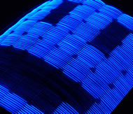
Wearable computing is another component of pervasive computing. Philip Ball reports in the Nature News Service website of a new optical-fibre fabric.

'Researchers at France Telecom have developed a fabric woven from plastic optical fibres that glow with a series of different images, like a TV screen […] you could use a mobile phone to download a whole new look into the fabric from a computerized database.
The battery-powered optical-fibre fabric should "open new horizons for fashion designers," say its developers Emmanuel Deflin and co-workers of France Telecom in Meylan. In a more practical vein, they suggest that fire-fighters or police could wear clothing programmed to display safety or warning information visible from afar.
So far the team has made a jacket containing a very low-resolution grid of eight by eight pixels, which displays crude yet readable symbols such as numbers.
Switchable textiles have been made before from different light-emission devices. In principle, flexible and fully pixellated screens could be imprinted onto fabrics using plastic light-emitting diodes (LEDs), for example. But fibre-optics are tough, cheap and easy to adapt to existing fabric-weaving technology.
Showing real movies on this fabric is, in truth, still remote. A TV or monitor screen contains a grid of pixels that can be lit up or left dark. Each fibre-optic thread in the fabric provides an entire row of pixels that can be configured in only one way. The row can be set up to contain some unlit and some lit sections when switched on, but that predetermined pattern can't be changed.
For a screen capable of supporting several different images, therefore, a different thread must supply each different configuration of light and dark patches in a row of pixels. This is not quite as limiting as it sounds, because the fibre-optic threads are little thicker than a human hair at about a quarter of a millimetre across.
The screen could support four distinct patterns, for example, by selecting one of four strands for each line of the image. The glow from each bright part of a strand spreads out enough that, from a distance, the intervening dark strands are barely visible. Primitive moving images can be made by rapidly switching between several such pre-set pictures.
The threads are optical fibres that leak light along the sections that need to glow. Normal optical fibres trap light inside, so that they look transparent from the side but glow at the far end where the light emerges.
A French company called Audio Images has developed a way to perforate optical fibres with tiny holes that allow some of the light to escape sideways. Each section of a fibre then glows when light is fed into one end.
Deflin's team uses plastic fibres, which are stronger than the glass fibres used for telecommunications. Light is fed into the fibres by tiny LEDs along the edge of the display panel and controlled by a small microchip. LEDs of different colours can be used for multicoloured images.'

Ambient computing and devices

The Play Group - informative art and slow technology
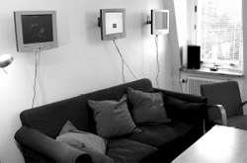

The PLAY research studio investigates and invents the future of human-computer interaction. As computers become more and more a part of everyday life, the previous view of computers as strictly a work-oriented tool will change.

They believe that in the future, computation will become just another material for design, and take a natural place in human existence alongside other basic technologies such as writing and electricity.

'Within the research project Slow Technology, conducted at the PLAY group at the Interactive Institute in Sweden, we are experimenting with time as a variable in interface design, beyond the point of trying to minimize the time taken to perform a certain task. Instead, we want to design technology that encourages moments of reflection and mental rest by being slow, i.e, to provide food rather than fast food for thought.
'As a way of creating instances of slow technology, we are trying to develop Informative Art, where we are experimenting with how 'pieces of art' can be made to explicitly present information about their environment. Normally when creating an information visualisation, one can optimise the presentation in order to achieve maximum efficiency and readability. In informative art, the structures carrying the information have to be designed with other considerations in mind, as the resulting presentation should be able to take the role of a piece of art on display at, for instance, an office. This project addresses several important issues, e.g. what and how digital information can be mapped to real-world objects without fundamentally changing their existing role and usage.'

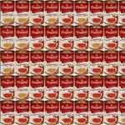

Informative Art borrows from the language of traditional art to create digital displays that convey dynamic information. For example, a screen-based abstract image mounted on a wall can be made to indicate the amount of unread email.

Ambient devices

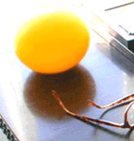

Ambient computing offers non-invasive computing, by placing objects in the environment that can be made to provide any information the allied software is programmed to track. For example, already available from one company are an ambient glowing orb (operating wirelessly using a radio frequency) that can track stock market fluctuations (or any other transient information) by changing colour. Also available are a rotating pinwheel that spins faster with each incoming unread email, and a pen, watch panel and keyfob that work in similar ambient fashion. What these are trying to achieve is a computing environment where we don't have to 'open' the computer to obtain information; where a quick glance, or the detection of a certain sound, or (through touch) level of vibration will indicate the state of the information we are seeking.

LCD paint
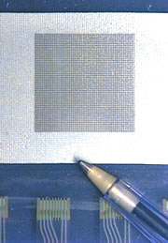

In an article from the Nature News Service website Helen Pearson reports on LCD Paint.

'Homes of the future could change their wallpaper from cream to cornflower blue at the touch of a button, says Dirk Broer. His team has developed paint-on liquid crystal displays (LCDs) that offer the technology.
Liquid crystals are peculiar liquids: their molecules spontaneously line up, rather than being randomly orientated as in a normal liquid. Passing a voltage across the molecules switches their alignment, blocking the transmission of light so a display changes from light to dark.
Current LCDs on digital watches, mobile phones and laptops sandwich the crystal between heavy glass plates. The complicated production process is time-consuming, expensive and restricts the size of screens to just 1 metre square.
Broer and his colleagues have devised a new open-sandwich technique that instead deposits a layer of liquid crystal onto a single underlying sheet. Working at Eindhoven University of Technology and Philips Research Laboratories in the Netherlands, Broer's team has already produced prototypes on glass and plastic; fabric could be next.
The technique could create giant TV screens, digital billboards and walls that change colour. Slim, plastic LCDs sewn into fabric could display e-mail or text messages on your sleeve. "It depends what future societies want," says Broer.
The technique should feed people's thirst for smaller, cheaper gadgets. Conventional glass LCDs now make up an increasing part of a laptop's weight - plastic versions could change that, says Peter Raynes, who studies LCD technology at the University of Oxford, UK.
Broer's team made the LCD paint by mixing liquid crystal with molecules that link together into a rigid polymer when exposed to ultraviolet. In a two-stage process they effectively build tiny boxes holding the liquid1.
They coat a glass or plastic base with a thin layer of the LCD paint and mask out squares so that a blast of ultraviolet forms a grid of walls. When they remove the mask, a second exposure - at a wavelength that does not penetrate the whole liquid layer - seals over the boxes with a lid.
Standard LCDs, which are divided up into pixels, turn dark when a voltage crosses between electrodes on the two glass plates. The new displays instead pass voltage between two points on the same plate. Colour LCDs fit each pixel with red, green and blue colour filters.
"Don't expect to buy a watch featuring one of the new displays in the next six months," warns Raynes, however. He cautions that the technique needs work: compared with glass, the thin outer layer may be more easily penetrated by oxygen or water that degrade the crystal.'

Networks
A key component necessary to the development and implementation of pervasive computing are network infrastructures.

The Sapient Corporation is researching the development of intelligent networks. These consist of the following components:

The network
The separation of media and control at the network level will enable dynamic aggregation and delivery of media and services to the most appropriate device via the most appropriate distribution channel.

Network services
Next-generation network protocols and architectures, such as those for distributed systems, will enable the emergence of network services, the definition of users as network services, and the dynamic aggregation of network services.

Network users
The representation of users as permanent network identities and use of intelligent agent technology on the user’s behalf will enable dynamic interaction between multiple users and services within a single context.

Network devices
Fixed and mobile devices, such as PCs, PDAs, TVs, and cell phones, will evolve from functioning individually within a single context to functioning as a collection of related networked devices that share a single context.

Network distribution channels
The maturation of fixed and mobile distribution channels, such as powerline, xDSL, and cellular, and the separation of control and media will enable the emergence of seamless bandwidth.

Conclusion
The vision of pervasive computing in an increasingly networked environment is the most likely future scenario for integrating computing into everyday life. There are issues to be addressed, some of them considerable, but the advantages to disabled users are immediately apparent. Intelligent environments, computer control by everyday activity, and the linking of devices wirelessly all contribute to an ease of use that seems to belong to a distant future. But despite the advanced appearance of the pervasive computing vision, much of the necessary technology is already capable. How regional, national, social and cultural factors will influence the technologies and promise of pervasive computing remains to be seen.

http://sdforum.org/p/calEvent.asp?CID=751&mo=4&yr=2002
Mark Weiser, Chief Technologist of Xerox PARC, Palo Alto Research Center (PARC), the company's renowned high-technology incubator is widely regarded as the 'father' of ubiquitous computing; his web page contains links to many papers on the topic: http://www.ubiq.com/hypertext/weiser/UbiHome.html.
http://www.computer.org/pervasive/
http://web.media.mit.edu/~neilg/
'Beyond the Internet', published by the RAND Organisation http://www.rand.org/scitech/stpi/ourfuture/Internet/section4.html
http://oxygen.lcs.mit.edu/
http://cuneus.ai.mit.edu:8000/research/miketalk/miketalk.html if offline, see the technical paper: http://citeseer.nj.nec.com/ezzat98miketalk.html
http://www-lce.eng.cam.ac.uk/~dl231/
http://www-lce.eng.cam.ac.uk/~dl231/publications.html
http://www.usa.siemens.com/about/innovations/feature_stories/simpad_22801.html
http://www.nist.gov/smartspace/
http://www.itl.nist.gov/
http://www.nist.gov/
http://www.computer.org/pervasive/
http://www.nature.com/nsu/011122/011122-11.html
http://www.nature.com/nsu/010913/010913-3.html
http://www.nature.com/nsu/020520/020520-4.html
http://www.playresearch.com/
http://www.viktoria.informatik.gu.se/groups/play/projects/slowtech/installations.html
http://www.ambientdevices.com/cat/applications.html
http://www.nature.com/nsu/020429/020429-7.html
http://www-lce.eng.cam.ac.uk/~dl231/

